**Senior Capstone Project**

Evaluating Success of Technical Analysis Investment Strategies

Chapter 2: Bollinger Bands



Name: Benjamin Nicholson

School: Seton Hill University

Advisor: Dr Jared Burns

**Background**

The Bollinger Bands Investment technique is a popular technical analysis tool created by John Bollinger in the 1980's. They measure market volatility and utilize moving averages to understand whether a stock is overbought (price is high) or oversold (price is low). This can be used to create buy and sell signals which can be used by themselves or a part of more elaborate trading techniques in which they give insight into the price of the stock. Bollinger Band technique creates the following parameters:

- Middle band: The 20 day moving average

- Upper band: The 20 day moving average plus 2 standard deviations of the current moving average

- Lower band: The 20 day moving average minus 2 standard deviations of the current moving average

Bollinger Bands assume a weak confidence for the truth of the efficient market hypothesis which states that each stock is the exact representation of all market data. This would imply that under or over valued stocks do not exist and Bollinger Bands would be deemed as a futile investment strategy.

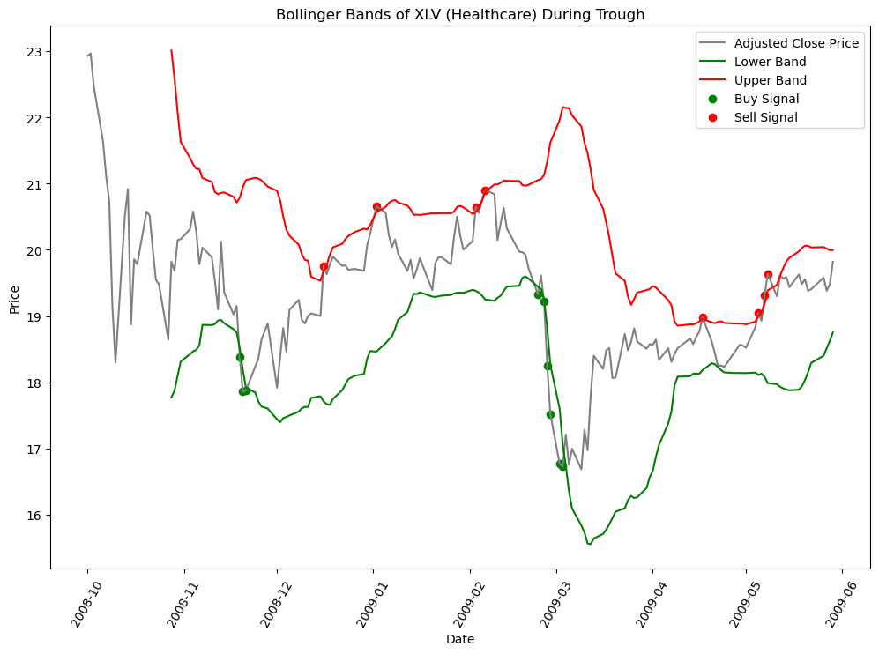

**Parameters**

Bollinger Bands are made up of two parameters which can be adjusted to return different results. They are made up of a rolling average which has a default of 20 days and a 2 standard deviation above and below the mean to create the upper and lower bands. Where the equation of the lines are.

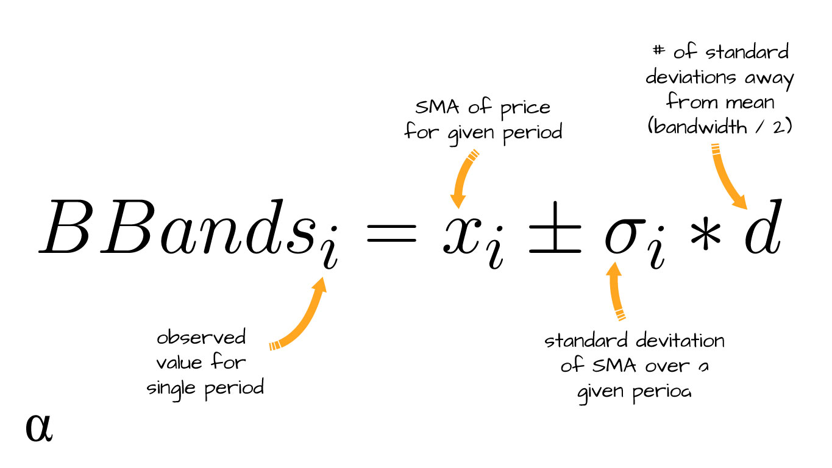

**Actions**

A buy signal is triggered whenever the rolling average falls below the lower band and a sell signal is triggered whenever the rolling averages rises above the upper band.

From the above example it creates the following signals.

Observe that signals usually come in intervals where there seems to be a strength towards the buy or the sell signal, based on the number of times the same signal has taken place.

**Stochastic Modeling**

Unlike chapter 1 where it was simply comparing the price at the end of the cycle compared to the start of the cycle, Bollinger Bands have multiple buy and sell signals which requires a structure of investing where multiple things need to happen at once.

The function needs to have access to signals and adjusted closed price. The two sheets are used simulatenously using a zip function to match the row and column index, this will then be repeated for each period. This process will be for 110 days as it takes 90 days for the initial time to come into play before, this ensures that each method has access to the same amount of time to yield returns. There is the option of having stock already bought or you buy and sell as of day one. Each stock is testing independtly of one another with a fixed 0.20 percent of funds to buy and a 0.20 percent of funds to sell.

**Results**

Base Model

20 day rolling average with a standard deviation of 2 above and below the rolling average

*Image 1: Expected returns from stochastic modeling using Bollinger Band Base Model*

Hyperparameter Optimization Bollinger Bands Model

A rolling window of 30 with a confidence interval of 0.90 (1.640 std)

*Image 2: Expected returns from hyperparameter optimization for Bollinger Band Model parameters*

**Price Investment Optimized Model**

*Image 3: Expected returns from hyperparameter optimization for price investment for buy/sell actions*

Initial Investment with Bollinger Band Investing

**Discussion**

